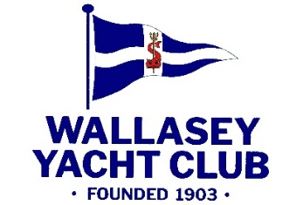

Regatta Weekend 2026 Entry Form

Enter Yacht .......................... in Class .................................
Sail Number .......................... Class ....................................
Rig .................................... Colour of Hull ..........................

Please enter me for: Saturday ...... Sunday ...... (Please tick days)

I am in possession of a valid class/racing certificate for the yacht.

Handicap Dinghies:
Portsmouth Number ..................................................................

Handicap Yachts:
C.H.S. Rating ..................................................................

General:
I have given attention to the regulations as to the sea worthiness, safety precautions and equipment. I understand that I am responsible for the sea worthiness of the yacht and that all on board will take part in the race at their own risk. All boats must have adequate buoyancy and personal buoyancy must be of an approved design and worn at all times whilst afloat. I agree to be bound by the I.S.A.F. Racing Rules of Sailing, R.Y.A. prescriptions and by the WYC sailing instructions.

I declare that I hold a valid current Certificate of Insurance with a minimum of £3,000,000.00 Third Party Cover whilst racing .

Signature ....................................................................................
Owner’s Name (BLOCK CAPITALS) ........................................................
Address ......................................................................................
...................................................... Post Code .............................
Club .........................................................................................

Date ................... Entrance fee enclosed: £5.00 for 1 day / £8.00 for 2 days

Boat Storage: Some boat storage is available at WYC. Please note that users of these facilities do so at their own risk. WYC will not accept any responsibility for or liability whatsoever for personal injury, damage or loss to boats, equipment or personal property.

